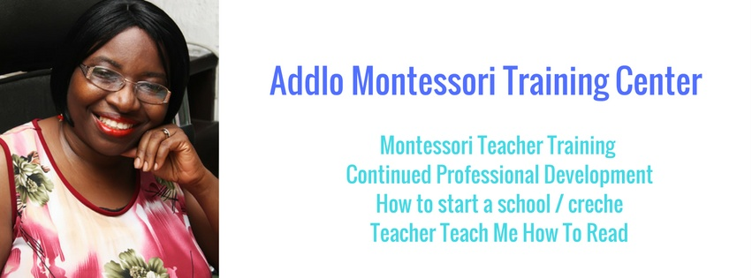

STARTING YOUR PROFITABLE MONTESSORI SCHOOL.
A step by step guide to successful implementation.
Your Passion, your story.
You are undertaking a very wonderful journey of starting a school. Well done, and thank you for including us in your journey. We are here to support you and ensure that you reach your greatest potential as you start your school.
There are important steps you need to take to reach your goals. This worksheet is the first of several please do the work and respect that this is freely but jealously given. It is for your eyes only. Please do the work and get the results. It’s your choice. Read through and then take a break, get out your pen and paper and start crafting your Passion. With your passion and story written down you will find your message. The true journey to starting the school would have begun. Sometimes its not the building, classroom, painting etc. that matters but your message and passion, that is the true heart of your business. Take the time out to do the work now.
So here goes:
If you do not know why you are starting a school you will not be able to craft your Mission statement, your business vision, nor sell your services to the Parents that work through your door.
At the end of the day your goal is to sell spaces in each classroom to your prospective parents. They want to know why they must choose you above every other school in the neighbourhood.
So how do you convince them that your school is the place for their child?
The answer is through your message?
So what is your message?
- Step aside and think for a moment: Why do I want to start a school?

If you have started a school already why did you start the school?
You could have decided to do something else with your life, but you chose to start as school. Why?
Write down all the reasons that come to mind.

It is important that you have a clear understanding about your motives right at the beginning. Apart from the fact that you need to be able to communicate this clearly to your prospective clients (this will be what inspires parents to register their children in your school- they must know what motivates you, so you must always be ready to share this with them), you also need to have deep clarity, because this may be the only thing that will keep you going when things are not going so well. There will be days when you will feel discouraged, it is your why you started it that will keep you going during those rough patches.

So pause for five minutes and put pen to paper and write down your Why…

- What past experiences have you had that has made you passionate about starting a school?

I for example did not think about this until I came across Montessori as a method of education, and a light bulb went on in my head. Every ones experience is different what is yours?

- Describe the problem the frustration. For me I hated school and did not want to go into education because I had found school boring as a child and did not want to become a boring teacher.
- Look for the defining moment that you found a solution to this frustration and made you decide to make the choice of starting a school: For me the solution was finding Montessori! It provided the answer. I have not looked back.
- List the exciting benefits of your decision: What do you see the children your school nurtures become, how are you going to impact their lives.
Here is my story in a nutshell: When I was growing up my parents always said ‘You should study education and become a teacher!’ My answer to this was always ‘No way’. Why would I want to become one of those boring teachers. I always hated school when I was growing up. So I went to Uni and studied Theatre arts. I love singing, dancing and acting, so I loved theatre school. Once I graduated though I kept getting teaching jobs! First as a lecturer, then as a Sunday School teacher then even as a nanny to a one and a half year old, but I did not get the message until much later when I started a children’s entertainment business and in my quest for more knowledge about age appropriate toys for children I stumbled upon Montessori. I couldn’t believe it! So there was actually a way to teach kids that was fun? And children can learn so much and know so much without stressing them out! …. This is where I start listing in brief the benefits of a Montessori education.
Parents love this. It speaks to them.
Now start writing your story.
Share your answers with me during our next talk.

