Module 7 Lesson 1
The Teens Board and other materials for the presentation.

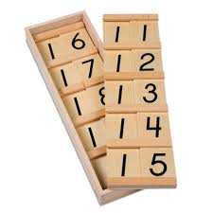

This is a box with 2 boards divided into 5 compartments with 10 written in the five compartments of one board and in the first four compartments of the second board. There are 9 sets of cards or wood chips with one of the numbers 1 to 9 written on them, these slide into the compartments and cover just the 0 parts of the ten.

You will also need 9 or 45 ten bars
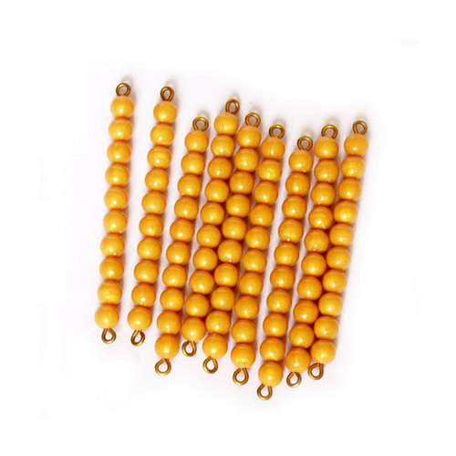

and 9 or 45 unit beads
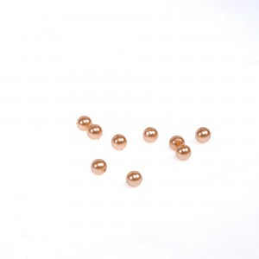

(or a set of short bead stairs)

