Module 6 Lesson 1
The introduction to the decimal system: the materials needed.

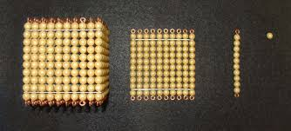

The Montessori golden bead materials are one of the most useful mathematical hands on materials in my own view that makes Montessori fun and keys into the concrete to abstract formula that makes understanding maths so easy in our settings.
The introductory materials for first presentation are
1 single unit golden bead
1 ten bar
1 hundred square
I thousand cube
All made of golden beads.

You will also need the number symbols
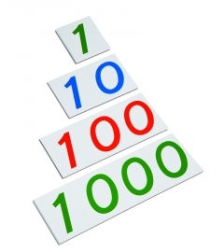
They are colour coded
I – Units – Green
10 – Tens – Blue
100 – Hundreds – Red
1000 – Thousands - Green

