Month 8 Lesson 3

Geography Continued

FLAGS (small group presentation)

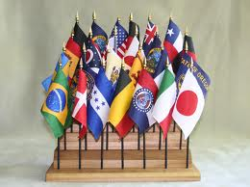

Material:
- Flags of the World.
- Sets for each continent, with flag stand and individual bases.

Objectives:
- To introduce the child to the names of countries.

Presentation:
- Show the child where the flags are kept. Tell the child these are the flags of different countries.
- Select a flag according to the child's interest, i.e., national flag, or the child may choose.
- Remove flag from its stand. Name the flag. Ask the child to walk naturally on the line with the flag held upright. The child may now carry the flag any time he wishes.
- Encourage the child to use other flags and learn their names.

Exercise 1: Once the child knows a few flags, approach him and ask him to tell you the names of his two favourite flags. Say, "I'll show you how to carry two flags on the line". Remove the two flags from their stands and hold one in each hand, carry one flag higher than the other. Walk on the line as before. Invite the child to carry the flags while walking on the line.

The Countries of the World

NORTH AMERICA
Canada Greenland United States of America Mexico Guatemala Belize Honduras El Salvador Nicaragua Costa Rica Panama Cuba Jamaica Haiti Dominican Republic
SOUTH AMERICA
Columbia Venezuela Guyana Suriname French Guinea Ecuador Brazil Peru Bolivia Paraguay Chile Argentina Uruguay
EUROPE
Portugal Spain France Andorra Monaco Iceland Ireland United Kingdom Belgium Netherlands Luxembourg Switzerland Italy San Marino Norway Sweden Finland Denmark Germany Austria Poland Czech Republic Slovakia Hungary Albania Greece Turkey Bulgaria Romania Liechtenstein Yugoslavia Slovenia Bosnia & Herzegovina Croatia Macedonia Russia Estonia Latvia Lithuania Belarus Ukraine Armenia Moldova Georgia Azerbaijan Turkmenistan Uzbekistan Tajikistan Kyrgyzstan Kazakhstan
ASIA
Oman Turkey Syria Lebanon Israel Jordan Iraq Saudi Arabia Kuwait Iran Yemen Arab Republic People Democratic Republic of Yemen Mongolia Afghanistan Pakistan India Nepal Japan China Bhutan Bangladesh Burma Thailand Laos Vietnam Cambodia Malaysia Indonesia New Guinea Sarawak Philippines South Korea North Korea

AFRICA
Morocco Algeria Tunisia Libya Egypt Western Sahara Mauritania Mali Niger Senegal Guinea-Bissau Guinea Sierra Leone Liberia Ivory Coast Burkina Faso Ghana Togo Benin Nigeria Chad Sudan Cameroon Central African Republic Ethiopia Djibouti Somalia Gabon Congo Zaire Uganda Kenya Rwanda Tanzania Angola Zambia Malawi Mozambique Namibia Botswana Zimbabwe South Africa Swaziland Lesotho Madagascar Gambia Burundi Rio Muni Swaziland Lesotho Eritrea
AUSTRALIA
Territories: 1. Western Australia 2. Northern Territory 3. South Australia 4. Queensland 5. New South Wales 6. Victoria
ANTARTICA Antarctica

Age: 2+ years

ANIMALS OF THE WORLD (small group presentation)

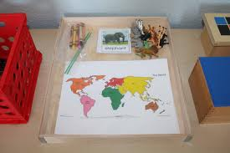

Material:
- Jigsaw puzzle map of the World.
- Three models of typical animals of each continent.

Objectives:
- To introduce the child to a wide variety of animals and teach the appropriate names.
- To relate animals to the continents on which they live.
- To stimulate interest in animals and ecology.

Presentation:
- Invite a small group of children to join you at a mat.
- Bring the basket of animals to the mat. Discover which animals the children can identify.
- For the remaining animals, give a three period lesson naming the animals. Use three or four animals at a time.
- Give a little information about each animal, which interrelates zoology and geography, and also animals and man. Information should concern the animal’s habitat and anything special regarding the animal i.e., penguins do not fly.
- Continue according to the interest of the children.
- Replace materials.

Exercise 1: Continue until all animal names are learned. Review previous work on animals.

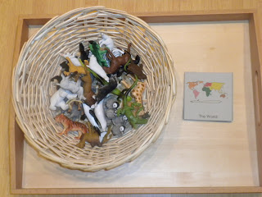

Exercise 2: After the children have been introduced to the animals, invite them to set out a mat, the map of the hemispheres and the basket of animals. Isolate an animal on the mat. Ask the children to identify the animal. Remind them of a special aspect and add where the animal lives. Invite a child to remove the continent from the map. Another child then places the animal beside the isolated continent. Continue in the same manner with other animals according to the interest of the children.

Exercise 3: Introduce card stories and pictures of animals. Discuss these pictures with the child, paying special attention to how each animal is equipped for its own particular environment. Keep a good selection of books in the classroom or direct the children to the library according to their interest. When they have reached the reading stage they can also place printed slips under the appropriate pictures.

Age: 3+ years

AFRICA

JIGSAW PUZZLE MAP OF AFRICA (small group presentation)

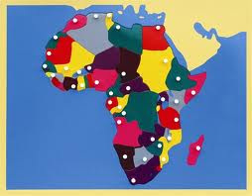

Material:
- Jigsaw puzzle map of Africa
- Picture Folder of Africa.

Presentation:
- Invite a small group of children to join you.
- Go to the map cabinet and say, "We are going to get the map of your continent". Remove the map and carry it to a mat.
- Remind the children their continent is Africa. "Let us get the globe and find Africa." Have a child locate Africa on the globe.
- Go back to the map and review with the children how to remove a piece of the puzzle carefully. For some of the large insets, hold them by the knob and slip the other hand under to further stabilize the puzzle inset.
- Have the children remove all the insets. Carefully replace them into the map.
- Give the names of the countries in a three period lesson. Include an interesting fact regarding each country to which the children can relate. Continue according to children's interest.

Exercise 1: As in presentation, continue until the children know the names of the countries and review the names of the oceans. Encourage the children to build the continent on the mat.

Exercise 2: After the children know the names of the countries and the oceans, tell them you have some pictures of the different countries. Ask the children to select a country for which they would like to see pictures. Remove a picture and engage the child in conversation. Repeat for another country according to the children's interest.

Exercise 3: Trace around the puzzle insets to make a map. Colour in the map or use coloured paper or fabrics.

Exercise 4: When the child is reading, introduce the printed labels. The child may also label his own map.

Exercise 5: Extend interest of children by doing a special presentation of pictures from countries in different areas in Africa, the north, south, east and west. Below are pictures contained in the South African Envelope.

